CS 455 - Software Engineering

Green Team

User’s Manual

Ricky Moore

Elizabeth McClellan

Hongbin Yu

James Reatherford

Ankur Patel

Wenhao Wang

University of North Alabama

2013/04/30

**Contents**

1. Faculty Use #

1.1 Logging in #

1.2 Lost/forgotten passwords #

1.3 Home Page & Selecting Semester #

1.4 Adding Preferences #

2. Admin Use #

2.1 Logging in #

2.2 Lost/forgotten passwords #

2.3 Semester Management #

2.4 File Input #

2.5 Account Management #

2.6 Generating Schedule #

**1. Faculty Use**

**1.1 Logging in**

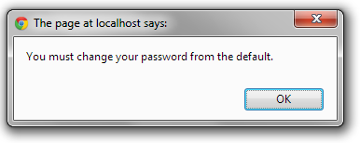

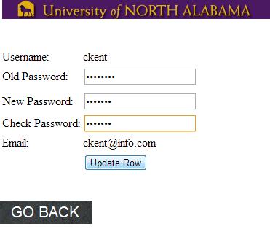

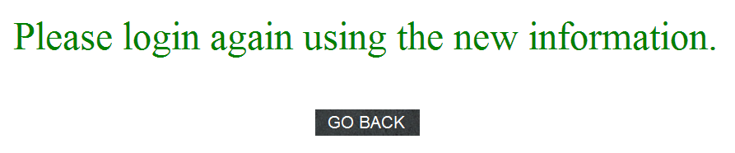

**1.2 Lost/forgotten passwords**

**1.3 Home Page & Selecting Semester**

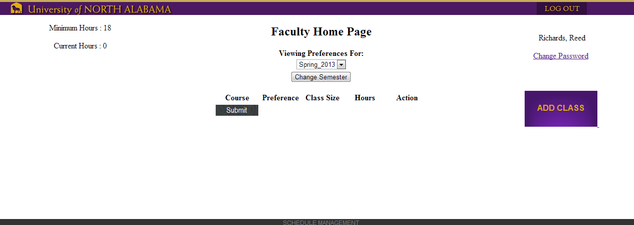

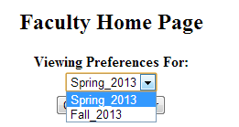

**1.4 Adding Preferences**

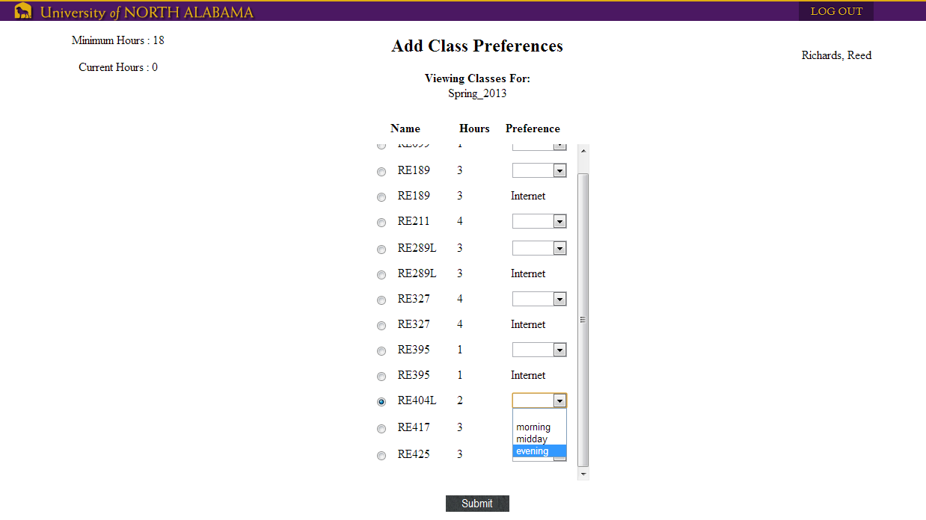

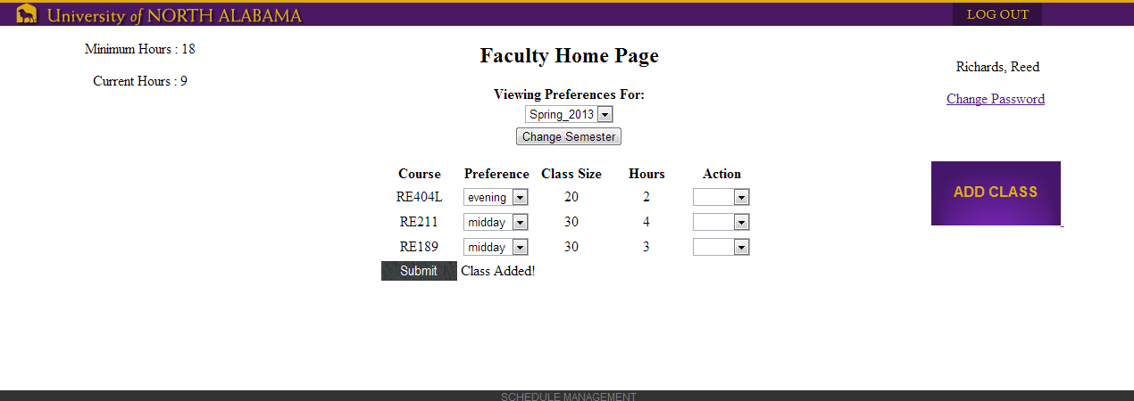

**2. Admin Use**

**2.1 Logging in**

Upon first login for either admin,

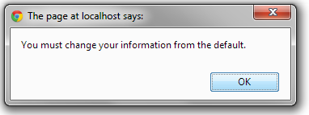

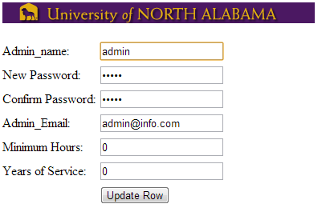

**2.2 Lost/forgotten passwords**

**2.3 Semester Management**

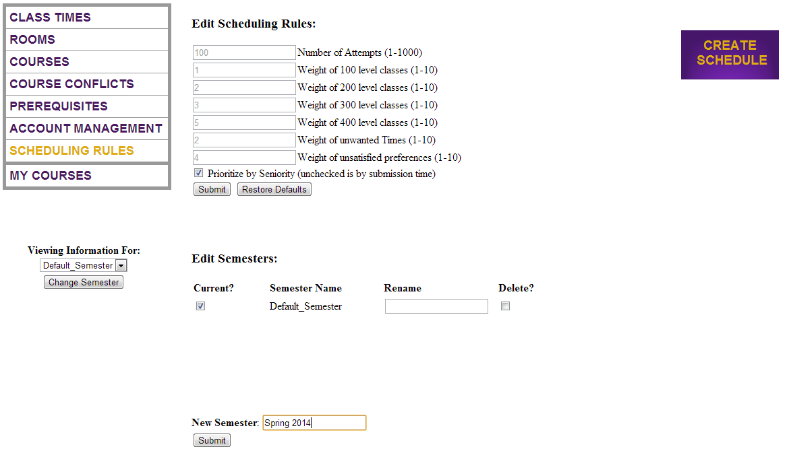

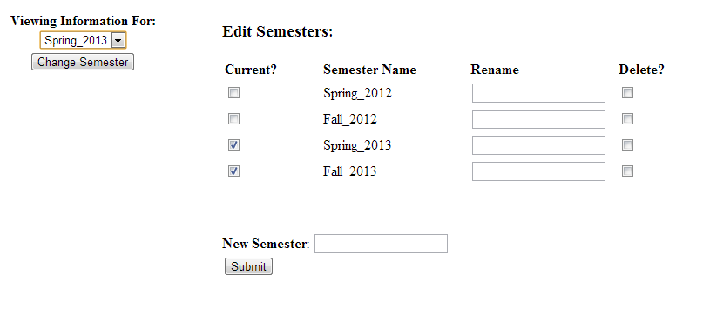

**2.4 File Input**

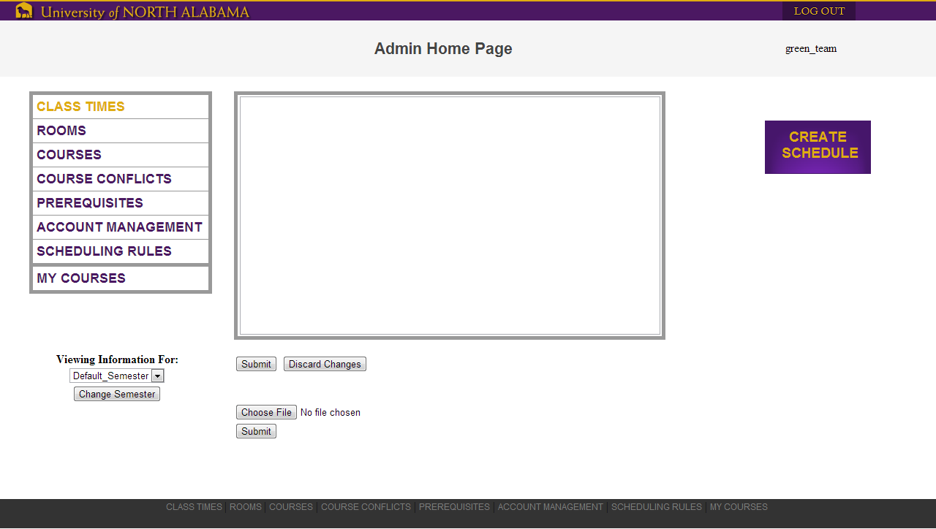



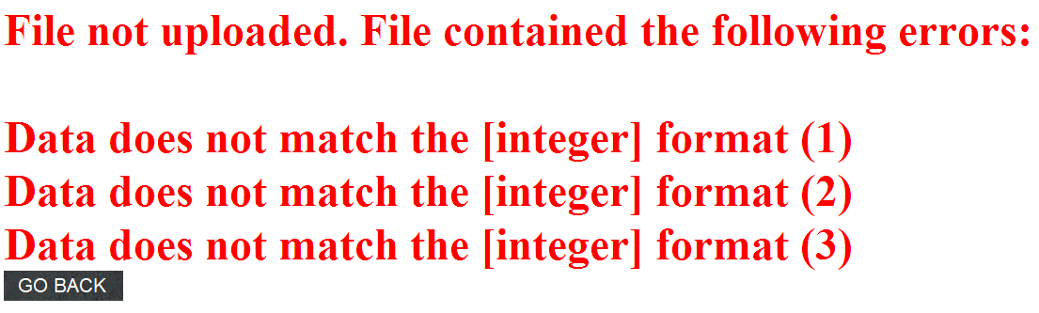

**2.5 Account Management**

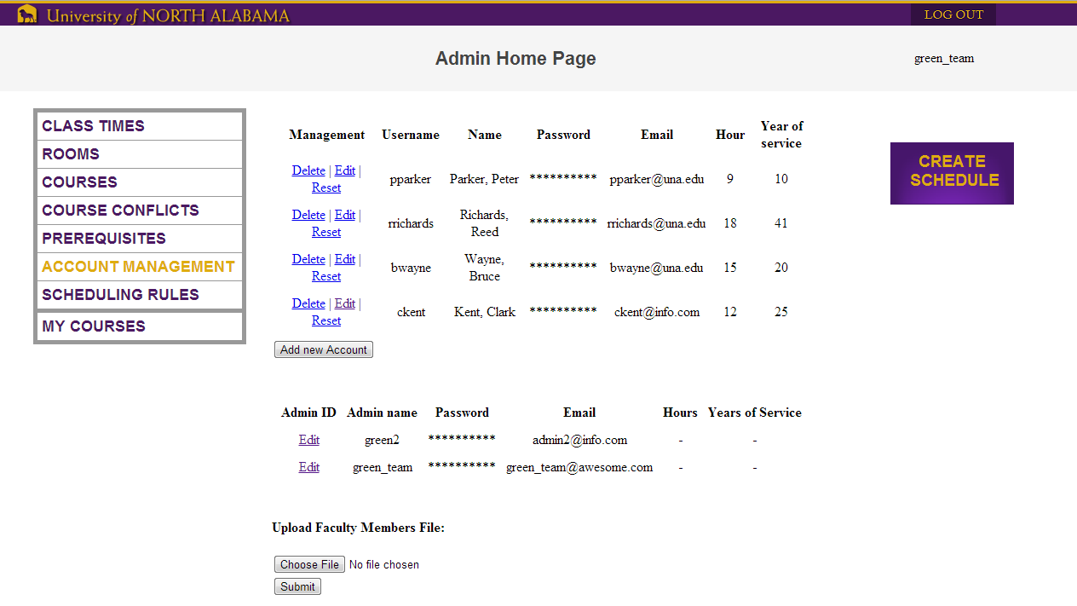

**2.6 Generating schedule**



